RAJALAKSHMI ENGINEERING COLLEGE

**RAJALAKSHMI NAGAR, THANDALAM – 602 105**



|  |
| --- |
| **CS23A34**  **USER INTERFACE AND DESIGN LAB** |
| **Laboratory Observation NoteBook** |

**Name :** SRIRAM UMAKANTHAN

**Year/Branch/Section :** II/CSE/D **Register No. :** 230701338 **Semester :** IV

**Academic Year:** 2024-25

**Ex. No. : 1a**

**Register No. : 230701338 Name : Sriram Umakanthan**

# Introduction to Figma (GOOD and BAD Design)

**Aim:**

To use Figma to create a simple mobile app login screen, including basic design and prototyping.

# Procedure:

## Step 1: Sign Up and Create a New Project

1. Go to figma.com and create an account (if you haven’t already).
2. Once logged in, click “New File” to start a blank project.

## Step 2: Create the Frame (Artboard)

1. On the left toolbar, select the “Frame” tool (shortcut: F).
2. Choose a mobile preset (e.g.,iPhone 13) from the righthand panel.

## Step 3: Design the Login Screen Add a Background Color:

1. Select the frame and go to the right-side panel.
2. Under “Fill” choose a background color (e.g., light blue).

## Insert a Logo:

1. Click the “Rectangle” tool (shortcut:R) and draw a placeholder for a logo.
2. Use the “Text” tool (shortcut: T) to add your app name, e.g., “MyApp”.
3. Adjust font size and color from the right-hand panel.

## Add Input Fields:

1. Use the “Rectangle” tool to draw two boxes for username and password fields.
2. Add placeholder text inside (e.g., “Enter your email”).
3. Apply rounded corners under “Corner Radius” in the right panel.

## Add a Login Button:

1. Create a button using the Rectangle tool and set the color to blue.
2. Use the Text tool to add the text Login inside the button.

## Align Elements:

Use the alignment tools in the top menu (center everything vertically and horizontally).

Adjust spacing between elements using the Auto Layout feature (Shift + A).

## Step 4: Prototyping the Interaction

1. Click the Prototype tab on the right panel.
2. Select the Login button and drag the blue dot to a new frame (e.g., a home screen).
3. Set the interaction to On Click → Navigate to the next screen.
4. Choose an animation effect (e.g., Smart Animate).

## Step 5: Preview the Design

1. Click the Play button in the top-right corner to preview your app prototype.
2. Try clicking on the login button to see the transition to the next screen.

## Step 6: Export Assets

1. Select the elements you want to export (e.g., the logo or button).
2. In the right-hand panel, click &quot;Export&quot; and choose a format (PNG, JPG, SVG).
3. Click “Export” to download assets for developers.

# OUTPUT :

## BAD DESIGN:

## C:\Users\HDC0422064\Downloads\download.png

This login page has a poor design due to several issues:

1. Inconsistent Font & Capitalization – The title and button text use inconsistent capitalization and an unprofessional font.
2. Misaligned Elements – The username and password fields are not properly aligned, making the layout look unstructured.
3. Poor Color Choices – The background color is dull and unappealing, reducing readability and visual appeal.
4. Random Image Placement – The icon appears unrelated and misplaced, adding to the clutter.

## GOOD DESIGN :

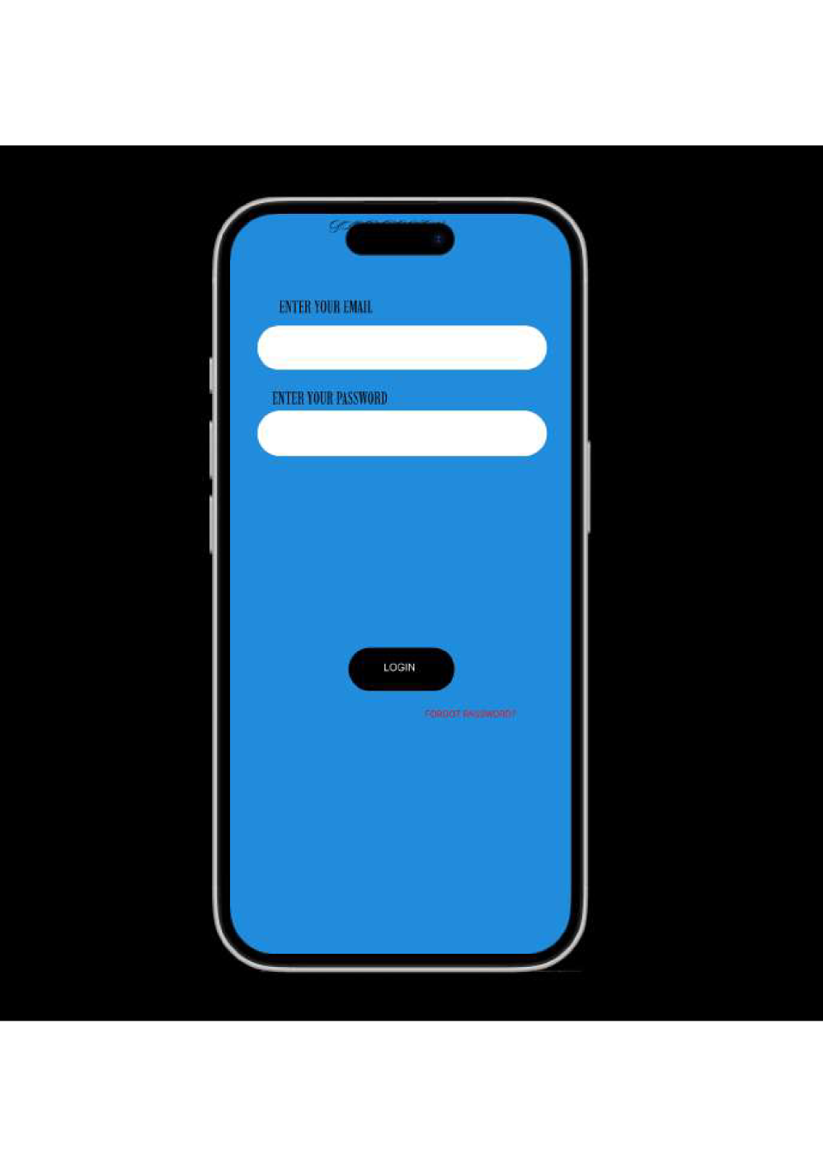

This login page has a good design due to several factors:

1. Clear Branding – The institution's logo and name are prominently displayed, ensuring credibility and identity.
2. Well-Aligned Elements – The username and password fields are properly aligned, making the layout structured and easy to navigate.
3. Good Contrast & Readability – The text is bold and legible, with clear labels for input fields and buttons.
4. Effective Button Design – The green "SUBMIT" and red "CANCEL" buttons use intuitive color coding for user actions.

# Proto type Link :

https://www.figma.com/proto/ZCExjzyH5AJhiI0KxBiZNa/Untitled?node-id=1-2&t=uLB0uZfNiWjYk5jE-0&scaling=scale-down&content-scaling=fixed&page-id=0%3A1&starting-point-node-id=1%3A2

# Result:

Hence the introduction to figma with good and bad design has been successfully studied and executed.